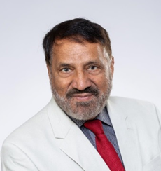

Jalal Chaudry B.Sc. (Edinburgh); M.Eng. (Birmingham); C.Eng. (London)
Candidate for the Treasurer

About me
I was born in India and came to Scotland from Pakistan in 1963 as a young child. My family was given a warm welcome by the local community they made us feel included and we decided to make this country our new home. I really feel proud and fortunate to have been brought up and educated in this country and would like to give something back to the people, and country which has given me such a great start in life.
The Labour Party embodies the values that I believe in; that of equality, co-operation and compassion. I have been long- life activist of the Labour Party and supporter of the trade union movement.
My experience
I have 25 years’ experience working in both the public and private sector as a Chartered Civil Engineer, also the treasurer of The Scottish Labour Party and Council of Ethnic Minority Voluntary organisations.
I have sat as South of Scotland and Lothian region representative on the Scottish Executive Committee (SEC) for 9 years.
I am former chair, vice chair, treasure, membership secretary and equality officer at Constituency Labour Party and branch level.
I am also actively involved with Help the Aged, Age concern charities,
If elected, I promise I will
- Create and utilize new methods to enhance party funding
- Keep party finances on a sound and transparent footing.
- Work to strengthen the relationship between the Labour Party and our Trade Union allies
Thanking you
Jalal

